Conmunis Conquest
(Working Title)
Game Pitch

Table of Contents

Foreword

Character

Class

Abilities

Levels

Equipment

Foreword

1.A Working title?
Why ‘Conmunis Conquest’? ‘Conmunis’ is latin for: common, collective, general, social, public, universal. Allowing for several play on-words with ‘Common Conquest’, ‘Collective Conquest’, ‘Collective Conquest’, ‘Social Conquest’ and ‘Universal Conquest’. All while offering unique brand identity, with only 223 google results for the two term search, ‘Conmunis Conquest’.
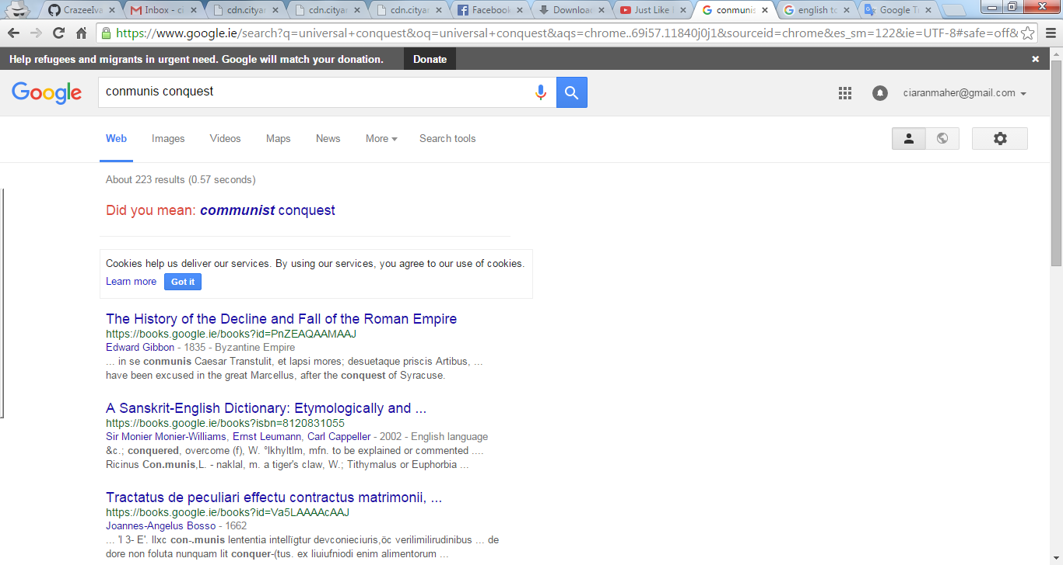

1.B Goals of the project
To create a game that provides intuitive and simple game-play on a micro level with a deep class system, procedural item generation and simulated physics across a massive sandbox universe. The complex class system layers a multi-role class system into a single character while still giving the player the ability to divide their “characters” into individual, specialised units. It is this system, combined with a universal economy that requires the harvesting, transportation and protection of both common and rare materials; that offers dozens of avenues of sand-boxesque game-play.
It is intended that this goal be met with the additional primary goal of creating a rich experience which being based on recent research, engages the player in areas of cognitive reasoning, memory and multi-tasking. This objective should come with the obvious implication that the game be approachable by gamers of all ages and backgrounds. The primary goals can thus be summarised as the following:
- Intuitive game-play and menus
- Simple but enthralling story elements
- Fun, vibrant and concise arcade action
- Immediate sound and visual feedback to all skills when used, when effective and when ineffective
- Procedural item generation
- Multi-class system
- Mothership allows universal class availability and increased customisability
- Single character/account system
- Immense world
- Physics based universe containing an evolving environment based on mathematical models
- Promote development of cognitive thinking, maths, fine motor control, memory and multi-tasking
- Playable with controller or mouse/keyboard
- Robust cross platform support with local and internet listen or dedicated servers.
- Scalable world
- Exciting and ruthless PvP/PvE encounters
- Evolves from a random seed

1.C Defini

